E-learning feedback – First step to the most important lessons of the past semester
Medical Faculty – Trakia University
Distance learning has put universities around the world to the test.
So far, various online platforms, electronic libraries and lecture courses have been created to benefit students for individual preparation when they are outside the training units.
Never before have studies been done on the effects of distance learning, how different platforms for online meetings and information exchange could be used, how the negative effects of social exclusion and distance learning can be minimized, and precisely through the technologies we have today.
In connection with the pandemic, a plan was created to learn the most important lessons we received in the course of distance learning, and as a first step, the feedback with students was chosen, which will be built for the benefit of future generations.
The survey was completed by 98 students
The students was divided by year of studying:
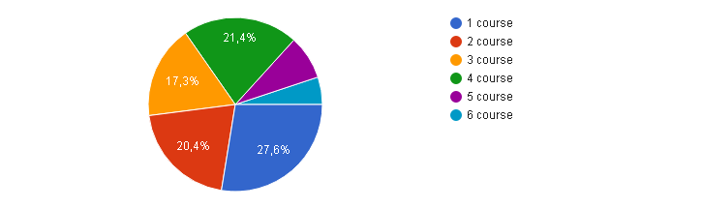

Did you attend the online lectures?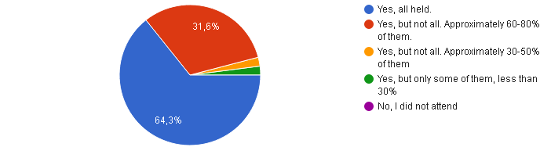

Which form of lectures was more useful for you?
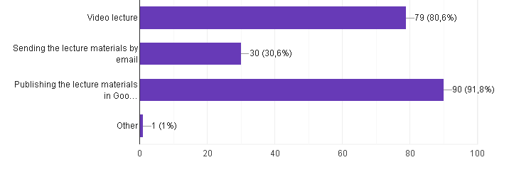Did you attend the practical classes?
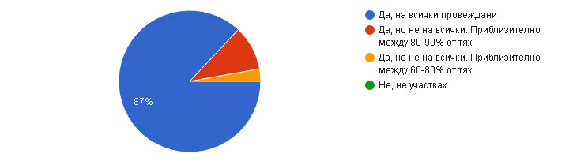Which form of practical classes was more useful?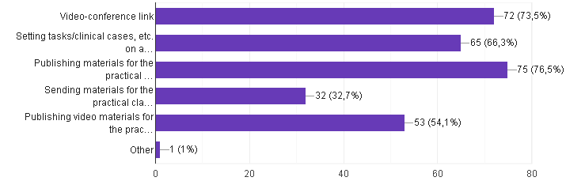
Where did you find materials for your studying during online learning?
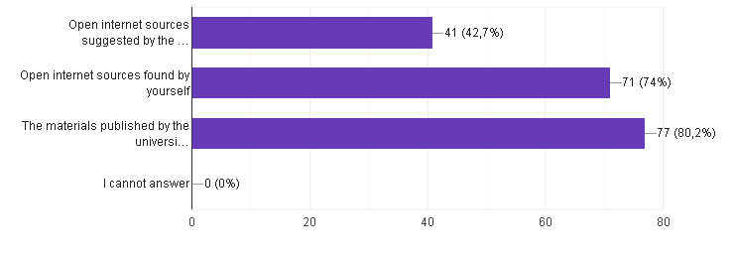
Did you have technical or other difficulties during online learning?
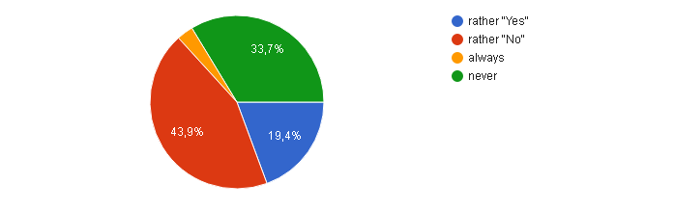
Overall, are you satisfied with online learning?
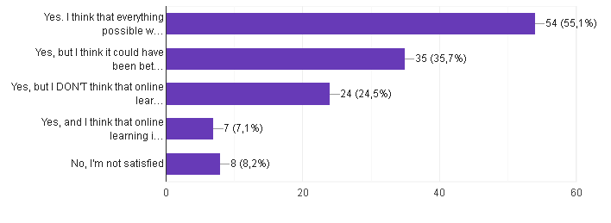

In your opinion, what were your extracurricular activities (engagements) during online learning?
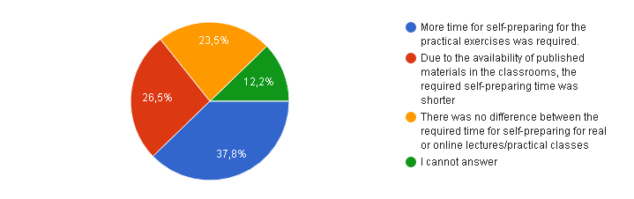
In your opinion, what were your extracurricular activities (engagements) during online learning?
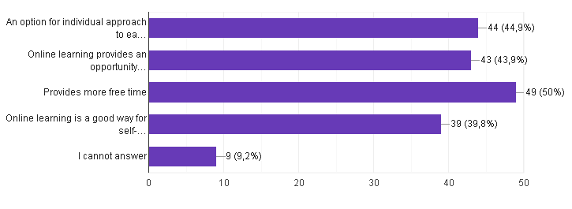

In your opinion, what makes online learning more difficult?
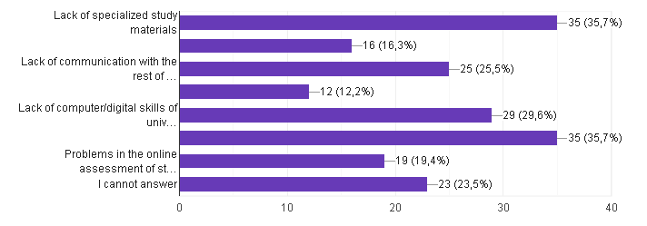
Please, indicate what type of communication with university teachers you used most often?
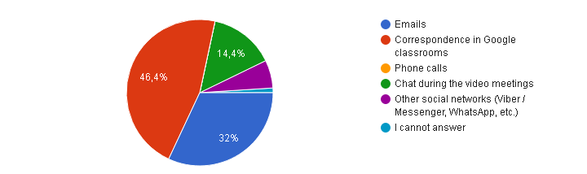
What is the most commonly used device in online learning by you?
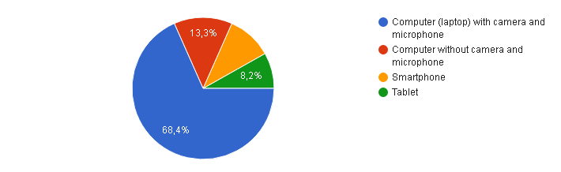

What is your final grade of conducted online training?
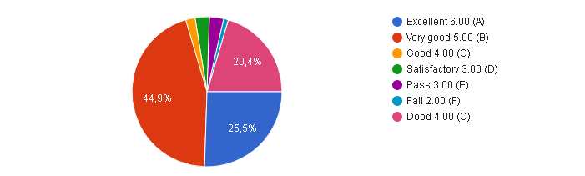
Do you think that it is appropriate for the lectures to be conducted entirely online, and the practical classes to be real (in person) in the current epidemic situation?
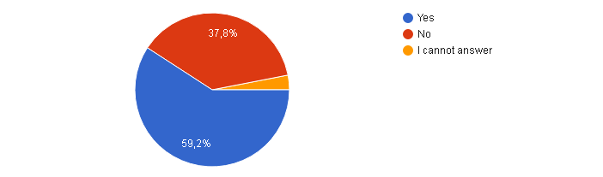
Some of the recommendations and additions from medical students:
-„It would be great if the practical classes were done online too, until the cases of covid are reduced.“
-„Personally I would feel much safer and comfortable doing all classes online due to the current spike and second wave of the virus, as medical students I think it is in our best interest to contain the virus my minimizing social interactions.“
-“Online classes worked, it was very good and I feel like we still learned a lot. In this epidemic situation it would be better for everyone’s health to study online. We know that the coronavirus is spreading and it’s very concerning.”

-“I learned more online than I did in person. It was easier to focus and hear the teacher and extra material was available to read as the teacher was explaining.”

-”In this situation, it is more responsible to make everything online. For students and staffs health.”
-“Online classes worked, it was very good and I feel like we still learned a lot. In this epidemic situation it would be better for everyone’s health to study online. We know that the coronavirus is spreading and it’s very concerning.”

